For more information, contact:

Karen Bernick, Director of Corporate Communications
kbernick@wodagroup.com
563-320-2625

Woda Cooper Companies Turns 30

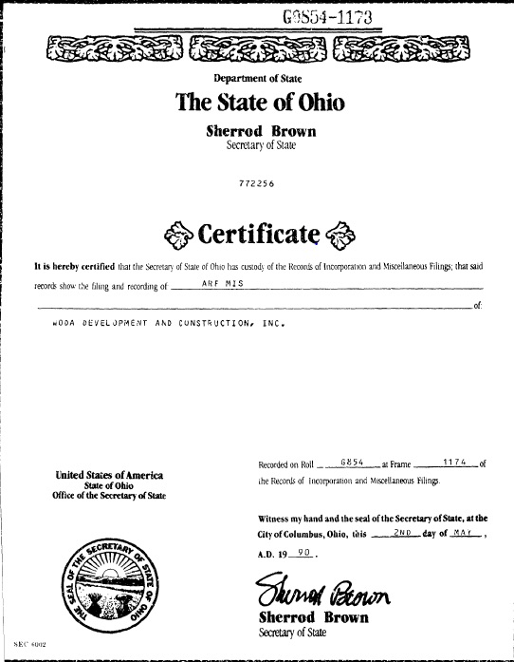
May 1, 2020, Columbus, OH...Affordable housing developer, builder, and owner Woda Cooper Companies marks 30 years in business on May 2, 2020. The company will honor the occasion with the release of a commemorative painting "30" created by a resident at the firm's mixed-use, mixed-income property Mallalieu Pointe in East Point, GA. In addition, the company launches a social media series highlighting the company's history.

On May 2, 1990, Woda Development and Construction, Inc. (WDCI) was started by Jeffrey J. Woda to develop and build multifamily properties and single-family homes. The first project was a rehabilitation of a four-unit multifamily in eastern Ohio that Mr. Woda’s father constructed in the early 1970s. David Cooper, Jr. was legal counsel.

"In those early days we talked a lot about the need for affordable housing and an opportunity to address that need using the emerging Low-Income Housing Tax Credit (LIHTC) program," said Mr. Woda and Mr. Cooper in a statement to industry colleagues.

In 1992, WDCI submitted a proposal to develop and construct Dutch Ridge, a 24-unit affordable community near Parkersburg, WV. Mr. Woda and Mr. Cooper eventually formed the partnership that would become The Woda Group, Inc. and later Woda Cooper Companies. Dutch Ridge remains in the Woda Cooper portfolio and was even rehabilitated a few years ago. The Dutch Ridge community is symbolic of Woda Cooper's operations and business plan.

"We believe in creating the best possible housing communities, then maintaining them for years into the future. In fact, we’ve only divested of one affordable property during our 30-year history," explained the two company principals.

Woda Cooper Companies has become one of the nation’s leading affordable housing firms, owned by its 700 employees through an ESOP (Employee Stock Ownership Plan). Today, Woda Cooper operates more than 320 affordable communities with 14,000 units for lower and moderate-income residents in 15 states.

"We are dedicated to developing, constructing, and managing high quality, sustainable communities that are highly valued in the locations we serve,” said Mr. Woda and Mr. Cooper.

On March 17, 2020, Woda Cooper announced the creation of an Interim Rental Assistance Fund in response to the coronavirus crisis, in lieu of a traditional anniversary celebration. Mr. Woda and Mr. Cooper maintain a positive outlook despite the pandemic that has deeply impacted the nation.

“We look to the future with optimism. We have retained all of our employees, created an interim rental assistance fund to help residents, and implemented safety policies to protect the well-being of our employees and residents. New developments continue to close on their financing as investors and lenders still appear eager to fund our developments.

“We are grateful for our strength during this time of uncertainty, and we deeply appreciate those who have helped us to achieve our success. We look forward to continuing our journey into the future,” said Mr. Woda and Mr. Cooper.

Painting "30" from Resident and Artist Ashley of ArtzyBella
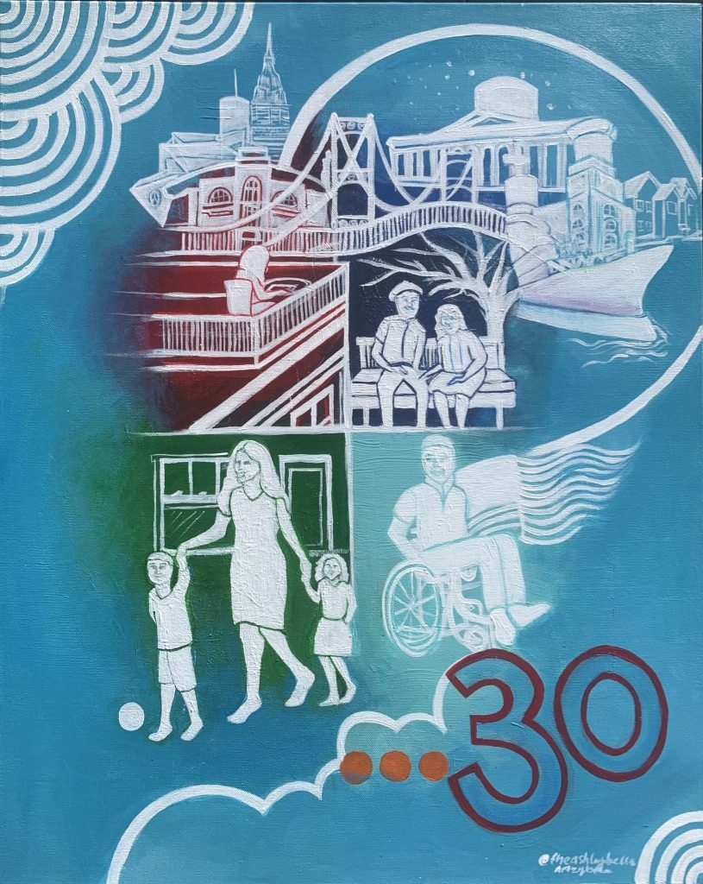
Georgia native artist Ashley Bella (Daramola) created the acrylic painting “30” to commemorate Woda Cooper Companies’ 30th anniversary. The painting represents a snapshot of the 100,000 residents served since the company’s start May 2, 1990. It also features many iconic locations in the affordable housing leader’s 15-state footprint in the Midwest, Southeast, and Mid-Atlantic.

The artist understands firsthand how affordable housing impacts a life. A few years ago, Ms. Daramola bravely left her job as a social worker to make her dream of becoming a full-time artist a reality. It wasn’t smooth sailing at first and she faced many sacrifices, like living out of her car before she could make ends meet as an artist. When she discovered an affordable apartment at Woda Cooper’s modern 67-unit Mallalieu Pointe in East Point, GA, it also opened a new door for her art career.

Watch a video about Ashley Bella Daramola by clicking photo.

At Mallalieu Pointe’s first-floor retail space, Ms. Daramola started ArtzyBella Studio + Shop where she sells murals, paintings, and other handcrafted art and hosts painting parties and workshops to help patrons develop creative skills. In addition to creating art, ArtzyBella works with local city governments to plan art events that engage people of all ages and Ms. Daramola’s alma mater Georgia State University recently awarded her a $10,000 prize to develop an art therapy kit.

“Being able to be in a LIVE-WORK space that is affordable, it allows me the cushion to pursue my dreams but still be able to take care of myself,” said Ms. Daramola.

Ashley Bella Daramola is just one example of the positive impact Woda Cooper Companies has made during its 30-year history developing, designing, building, and managing affordable communities.

Learn more about Woda Cooper Companies' history in a new series "Honoring 30 Years" on the company's Facebook, LinkedIn, and Twitter pages.

About Woda Cooper Companies, Inc.
Woda Cooper Companies, Inc. and its affiliates are experienced developers, general contractors, and property managers specializing in the design, construction, and management of affordable multi-family apartments, senior communities, and single-family homes. Considered leading experts in the affordable housing industry, the Woda Cooper team is known for producing and maintaining high quality affordable housing. Affordable Housing Finance ranked the firm 13th overall among Developers and 26th overall among Owners in its April/May 2019 issue. Woda Cooper Companies, Inc. has developed and currently manages 320 communities and 14,000 units, operating in 15 states. In addition to its Columbus headquarters, the firm has offices in Savannah, Georgia; Indianapolis, Indiana; Shelbyville, Kentucky; Annapolis, Maryland; Mackinaw City, Michigan; Charlotte, North Carolina; and Norfolk, Virginia.

